Wind Energy Forecasting

Develop a predictive model leveraging historical weather data to forecast wind speed and direction for optimizing wind energy generation

Niti Chovatia Kathan Patel Harshit Chodvadiya

# SOT, Computer Science and Engineering SOT, Computer Science and Engineering SOT, Computer Science and Engineering

*Pandit Deendayal Energy University Pandit Deendayal Energy University Pandit Deendayal Energy University*

Gandhinagar, India Gandhinagar, India Gandhinagar, India

[niti.cce21@sot.pdpu.ac.in](mailto:niti.cce21@sot.pdpu.ac.in) [kathan.pce21@sot.pdpu.ac.in](mailto:kathan.pce21@sot.pdpu.ac.in) [harshit.cce21@sot.pdpu.ac.in](mailto:harshit.cce21@sot.pdpu.ac.in)

# Prof. Soham Vyas Dr. Shakti Mishra

## SOT, Computer Science and Engineering SOT(HOD), Computer Science and Engineering

*Pandit Deendayal Energy University Pandit Deendayal Energy University*

Gandhinagar, India Gandhinagar, India

[soham.v@sot.pdpu.ac.in](mailto:soham.v@sot.pdpu.ac.in) [shakti.mishra@sot.pdpu.ac.in](mailto:shakti.mishra@sot.pdpu.ac.in)

***Abstract***

**Wind energy has become increasingly crucial in the global shift towards renewable energy sources, necessitating accurate wind speed forecasting for efficient energy production and grid management. This paper explores the historical significance of wind speed data, tracing its roots to early navigational practices and meteorological observations. In contemporary industries, the application of wind speed data has expanded significantly, particularly in the wind energy sector for turbine siting, layout design, and operational planning. Additionally, utility companies and grid operators rely on precise wind forecasts to balance supply and demand, ensuring grid stability and resilience. Beyond energy, wind speed data finds applications in aviation, construction, agriculture, and maritime sectors, influencing flight planning, structural design, crop management, and navigation. The paper reviews various wind power forecasting methods, including physical, statistical, and AI-based approaches, highlighting the challenges and advancements in wind energy integration. Furthermore, it discusses the implications of climate change on wind energy resources and the development of predictive models to optimize wind power generation. The study concludes by emphasizing the importance of wind speed data analysis for industry competitiveness, environmental sustainability, and societal well-being, advocating for the continued advancement of wind energy technologies and forecasting techniques**

I. Introduction

Wind energy has emerged as a crucial force in the worldwide shift toward renewable energy sources, challenging the traditional reliance on fossil fuels. The accurate prediction of wind speed, deeply rooted in centuries-old meteorological observations and navigational necessities, now serves as a cornerstone for efficient energy production and grid management. This dependence on precise data extends across a spectrum of industries, from wind farm developers strategically positioning turbines to utility companies meticulously balancing power generation and demand. By amalgamating various forecasting techniques—be they physical, statistical, or AI-driven—alongside effective supply chain management, the reliability and sustainability of wind power are ensured. Leveraging historical weather data, predictive models drive the optimization of wind energy generation, ushering in a future marked by resilience and environmental conscientiousness. This harmonious integration of technology, historical insight, and forward-thinking strategies underscores the transformative capacity of wind energy in shaping a more sustainable and resilient global energy framework. Physical methods utilize meteorological data and physical laws to predict wind speed and direction accurately. Statistical methods, on the other hand, rely on historical data to identify patterns and forecast future conditions. AI methods, such as Artificial Neural Networks (ANNs) and Long Short-Term Memory (LSTM) networks, analyze large datasets to make predictions. Hybrid approaches combine different forecasting methods to improve accuracy.

II. Literature Survey

Table 1 – Literature Review

| **Index** | **Date** | **Title** | **Author Name** | **Objective** | **Model** |
| --- | --- | --- | --- | --- | --- |
| **1** | **2018** | **Wind energy forecast with neural network** | **Jaume Manero** | **Renewable energy is intermittent by nature and to integrate this energy into the Grid while assuring safety and stability the accurate forecasting of the renewable energy generation is critical.** | **AR, ARMA, ARIMA** |
| **2** | **2019** | **Climate change impacts on wind energy** | **S.C Pryor** | **Assessing the potential impacts of global climate change on wind energy resources and operating conditions in northern Europe to inform future mitigation strategies and investments.** | **AOGCM** |
| **3** | **2019** | **Wind power forecasting using neural network: tuning with optimization techniques and errors analysis** | **Not specified** | **Enhancing wind speed and power prediction accuracy with neural networks optimized by PSO** | **ANFIC, ANN-LM** |
| **4** | **2020** | **A Review on wind power and speed forecasting techniques** | **Harsh, Dipak** | **Reviewing recent wind energy forecasting schemes, emphasizing classification based on prediction horizons** | **ARIMA** |
| **5** | **2020** | **A novel spatio-temporal wind power forecasting framework based on multi-output support vector machine and optimization strategy** | **Peng Lu, Lin Ye, Wuzhi Zhong, Ying Qu, Bingxu Zhai, Yong Tang, Yongning Zhao** | **Proposing a forecasting framework using ST-GWO-MSVM model and autoregressive models** | **ST-GWO-MSVM, AR** |
| **6** | **2021** | **Weather Forecasting Model** | **Enas Raafat Maamoun** | **The objective is to improve wind speed prediction accuracy to ensure efficient wind energy integration and mitigate financial losses.** | **Prediktoer, WPPT, WPAMS** |
| **7** | **2021** | **A Hybrid GA–PSO–CNN Model for Ultra-Short-Term Wind Power Forecasting** | **Jie Liu, Quan Shi** | **To solve the problem of wind power prediction caused by randomness and volatility, a hybrid GA-PSO-CNN prediction model is proposed in this study** | **MAE, MSE, and MAPE** |
| **8** | **2021** | **Optimizing scheme of wind energy predictions based on AI** | **Yagang Zhang** | **Introducing a wind speed prediction scheme utilizing advanced data decomposition and classification techniques, coupled with optimized neural network models** | **ANN, ARMA, ARIMA** |
| **9** | **2022** | **Wind energy forecasting with AI and big data** | **Erlong Zhao** | **Conducting a comprehensive survey to identify the evolution and current trends of big data and AI methods in wind energy forecasting, and assessing opportunities, challenges, and implications for future research and development.** | **SVM, SAM, VMD** |
| **10** | **2023** | **Implications of Climate Change on Wind Energy Potential** | **Tolga Kara** | **Climate change refers to long-term alterations in typical weather patterns that define both local and global climates.** | **CMIP3** |
| **11** | **2023** | **A Review of Modern Wind Power Generation Forecasting Technologies** | **Wen-chang-tsai** | **Enhancing short-term wind power prediction accuracy through advanced algorithms and evaluating various forecasting models for improved grid integration and energy distribution.** | **NWP, RWPF, ANN** |
| **12** | **2023** | **Prediction of Wind Power with Machine Learning Models** | **Omer Ali Karaman** | **This study employs ML techniques—ANN, RNN, CNN, and LSTM networks—to estimate wind power plant generation.** | **ANN, RNN, CNN, and LSTM** |
| **13** | **2023** | **Wind Energy Conversions, Controls, and Applications: A Review for Sustainable Technologies and Directions** | **M.A. Hannan, Ali Q. Al-Shewti** | **Recommendations for future improvement in the performance of wind energy-based converters are highlighted for a sustainable future for the wind energy system.** | **Wind energy conversion system (WECS)** |
| **14** | **2024** | **A structure for predicting wind speed using fuzzy granulation and optimization techniques** | **ShiWen Wang, Jianzhou Wang** | **Presenting a novel hybrid prediction system to enhance wind speed forecasting accuracy through unique data preprocessing methods and model optimization strategies** | **Not specified** |

1. Impact of Climate Change on Wind Energy**:** Climate shifts caused by human activity influence wind behavior, stressing the need for flexible energy planning. Adoption of renewable energies like wind becomes imperative for addressing climate challenges and ensuring long-term sustainability.
2. Wind Power Forecasting Techniques**:** Wind energy predictions rely on historical and forecasted data, employing a mix of physical, statistical, and machine learning methods. Blending these methods enhances forecast accuracy, especially for short-term outlooks.
3. Variability in Wind Speed Predictions**:** Projections indicate diverse wind speed changes globally by 2050, with some regions experiencing increases while others see decreases. Seasonal fluctuations and discrepancies among models pose challenges for wind energy project planning.
4. Integration of Big Data and AI in Wind Energy Forecasting: Leveraging big data analytics and AI improves wind energy forecasts by addressing complexities and tapping into unstructured data's insights.
5. Advancements in Ultra-Short-Term Wind Power Forecasting**:** Recent advancements in AI and deep learning propel ultra-short-term wind power predictions forward, aiming for heightened accuracy and more efficient data utilization.
6. Proposed Wind Power Generation Forecasting Model: A suggested forecasting model incorporates various data processing techniques and an efficient neural network architecture, bolstering the accuracy and adaptability of smart grid-connected microgrids.
7. Impact of Climate Change on Wind Power Production in Europe: Climate change is anticipated to induce minor shifts in wind power production across Europe by the century's end, with some regions benefiting and others facing challenges.
8. Wind Energy Conversion System (WECS) Overview: WECS encompasses turbine technologies and control systems optimizing power extraction based on varying wind speeds. Ongoing advancements in generator types and control mechanisms drive efficiency and reliability improvements.
9. Challenges in Comparing Wind Power Forecasting Methods: Variability in data presents challenges in evaluating forecasting techniques, necessitating improvements in wind power data collection and distribution infrastructure.
10. This paper explores the impact of big data and AI on wind energy forecasting, addressing opportunities, challenges, and future directions. It identifies four primary forecasting models with varying input requirements and accuracy levels. Emphasizing intelligent and hybrid methods, it highlights the fusion of big data analytics and mining for improved predictionscwind energy forecasting.
11. This comprehensive review assesses recent advancements in wind power forecasting, particularly focusing on ultra-short-term and short-term models based on AI and deep learning. It evaluates the state-of-the-art algorithms, compares hybrid methods, and highlights challenges such as data diversity and algorithm optimization.
12. This section discusses the proposed wind power generation forecasting model and the DSM algorithm. The data preprocessing involves normalization and the use of NWP variables, lagged wind power values, and wavelet packet decomposed wind power.
13. Tailored power functions for each turbine reduce errors, especially in critical regions. Techniques like Kalman Filters enhance wind data for accurate power prediction, while machine learning aids in understanding wind patterns for improved forecasting.
14. A study by researchers at KIT concludes that climate change will lead to small variations in mean wind power production across Europe by the end of the 21st century, with some countries experiencing higher changes. Increased variability and more frequent low wind phases are expected, posing challenges for wind energy production.

III. Methodology

*A. LSTM (Long Short-Term Memory):*

* LSTMs Long Short-Term Memory is a type of RNNs Recurrent Neural Network that can detain long-term depend encies in sequential data. LSTMs are able to process and analyze sequential data, such as time series, text, and speech. They use a memory cell and gates to control the flow of information, allowing them to selectively retain or discard information as needed and thus avoid the vanishing gradient problem that plagues traditional RNNs. Unlike traditional neural networks, LSTM incorporates feedback connections, allowing it to process entire sequences of data, not just individual data points. This makes it highly effective in understanding and predicting patterns in sequential data like time series, text, and speech. LSTMs are widely used in various applications such as [natural language processing](https://www.simplilearn.com/tutorials/artificial-intelligence-tutorial/what-is-natural-language-processing-nlp), [speech recognition](https://www.simplilearn.com/tutorials/python-tutorial/speech-recognition-in-python), and time series forecasting.
* Use of Model - L combination is employed for tasks such as image captioning, video analysis, and sequential data processing.
* Advantages:
  1. LSTM captures temporal dependencies in sequential data.
  2. CNN extracts spatial features from input data

*B. GRU (Gated Recurrent Unit):*

* GRU stands for Gated Recurrent Unit, which is a type of recurrent neural network (RNN) architecture that is similar to LSTM (Long Short-Term Memory). GRU has a simpler architecture than LSTM, with fewer parameters, which can make it easier to train and more computationally efficient.In GRU, the memory cell state is replaced with a “candidate activation vector,” which is updated using two gates: the reset gate and update gate. The reset gate determines how much of the previous hidden state to forget, while the update gate determines how much of the candidate activation vector to incorporate into the new hidden state.  GRU processes sequential data one element at a time, updating its hidden state based on the current input and the previous hidden state. At each time step, the GRU computes a “candidate activation vector” that combines information from the input and the previous hidden state. This candidate vector is then used to update the hidden state for the next time step.
* Use of Model - GRU is used for sequential data tasks like speech recognition, natural language processing, and time series forecasting.
* Advantages:
  1. Simpler architecture compared to LSTM, leading to faster training and inference.
  2. Effective in capturing long-term dependencies in sequential data.

*C. ARIMA (Autoregressive Integrated Moving Average):*

* ARIMA is an acronym for “autoregressive integrated moving average.” It’s a model used in statistics and econometrics to measure events that happen over a period of time. The model is used to understand past data or predict future data in a series. It’s used when a metric is recorded in regular intervals, from fractions of a second to daily, weekly or monthly periods. ARIMA is a type of model known as a [Box-Jenkins method](https://machinelearningmastery.com/gentle-introduction-box-jenkins-method-time-series-forecasting/).

There are two prominent methods of time series prediction: univariate and multivariate. 1. Univariate uses only the previous values in the time series to predict future values. 2. Multivariate also uses external variables in addition to the series of values to create the forecast. The ARIMA model predicts a given time series based on its own past values. It can be used for any nonseasonal series of numbers that exhibits patterns and is not a series of random events

* Use of Model - ARIMA is widely used in forecasting economic, financial, and environmental data.

* Advantages:
  1. Captures linear relationships and patterns in time series data.
  2. Requires minimal data preprocessing.

*D. SARIMA (Seasonal Autoregressive Integrated Moving Average):*

* SARIMA, which stands for Seasonal Autoregressive Integrated Moving Average, is a versatile and widely used time series forecasting model. It’s an extension of the non-seasonal ARIMA model, designed to handle data with seasonal patterns. SARIMA captures both short-term and long-term dependencies within the data, making it a robust tool for forecasting. It combines the concepts of autoregressive (AR), integrated (I), and moving average (MA) models with seasonal components. The Components of SARIMA – 1.Seasonal Component**:** The “S” in SARIMA represents seasonality, which refers to repeating patterns in the data. 2.Autoregressive (AR) Component**:** The “AR” in SARIMA signifies the autoregressive component, which models the relationship between the current data point and its past values 3. Integrated (I) Component: The “I” in SARIMA indicates differencing, which transforms non-stationary data into stationary data. 4.Moving Average (MA) Component**:** The “MA” in SARIMA represents the moving average component, which models the dependency between the current data point and past prediction errors. It helps capture short-term noise in the data.
* Use of Model - SARIMA is employed in forecasting seasonal data such as monthly sales, quarterly revenues, and yearly temperatures.
* Advantages:
  1. Accounts for seasonal variations in time series data.
  2. Provides accurate forecasts for seasonal patterns.

*E. XGBoost (Extreme Gradient Boosting):*

* [XGBoost](https://xgboost.ai/), which stands for Extreme Gradient Boosting, is a scalable, distributed [gradient-boosted](https://en.wikipedia.org/wiki/Gradient_boosting) decision tree (GBDT) machine learning library. It provides parallel tree boosting and is the leading machine learning library for regression, classification, and ranking problems. It’s vital to an understanding of XGBoost to first grasp the machine learning concepts and algorithms that XGBoost builds upon: supervised machine learning, decision trees, ensemble learning, and [gradient boosting](https://developer.nvidia.com/blog/gradient-boosting-decision-trees-xgboost-cuda/). Supervised machine learning uses algorithms to train a model to find patterns in a dataset with labels and features and then uses the trained model to predict the labels on a new dataset’s features.
* Use of Model - XGBoost is used in various machine learning tasks such as classification, regression, and ranking.
* Advantages:
  1. Handles missing values and outlier detection efficiently.
  2. Provides high prediction accuracy and is less prone to overfitting compared to traditional decision trees.

*F. CNN+LSTM:*

* CNN+LSTM is a hybrid model combining CNNs for spatial feature extraction and LSTMs for sequential data processing. It is used for tasks involving spatiotemporal data analysis. This architecture involves using Convolutional Neural Network (CNN) layers for feature extraction on input data combined with LSTMs to perform sequence prediction on the feature vectors. In short, CNN LSTMs are a class of models that are both spatially and temporally deep and sit at the boundary of Computer Vision and Natural Language Processing. These models have enormous potential and are being increasingly used for many sophisticated tasks such as text classification, video conversion, and so on. Here is a generic architecture of a CNN LSTM Model.
* Use of Model – CNN LSTM is used in analyzing spatiotemporal data and more.
* Advantages:

1. Effective Feature Extraction**:** CNNs can efficiently capture spatial patterns in data, while LSTMs can effectively model temporal dependencies, resulting in comprehensive feature representation.
2. Robustness to Noise: The hierarchical feature learning of CNNs combined with the memory retention of LSTMs enhances the model's robustness to noisy or incomplete input data.

V. Result

The evaluation of various models for forecasting tasks provides insightful observations regarding their performance and suitability for different applications.

*A. LSTM (Long Short-Term Memory):*

* Root Mean Squared Error (RMSE): 0.37157121300697327

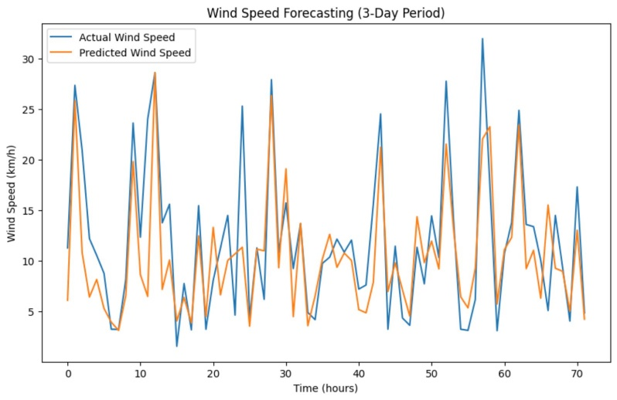

Fig. 1 Wind speed Forecasting (3 – Day period) - LSTM

*B. GRU (Gated Recurrent Unit):*

* Root Mean Squared Error (RMSE): 0.5262419316269058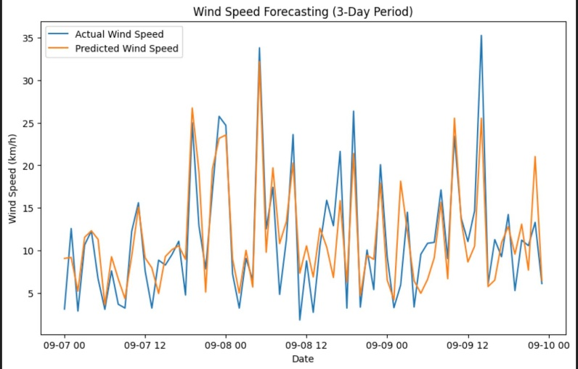

Fig. 2 Wind speed Forecasting (3 – Day period) – GRU

*C. ARIMA (Autoregressive Integrated Moving Average):*

* Root Mean Squared Error (RMSE): 9.660674913416363

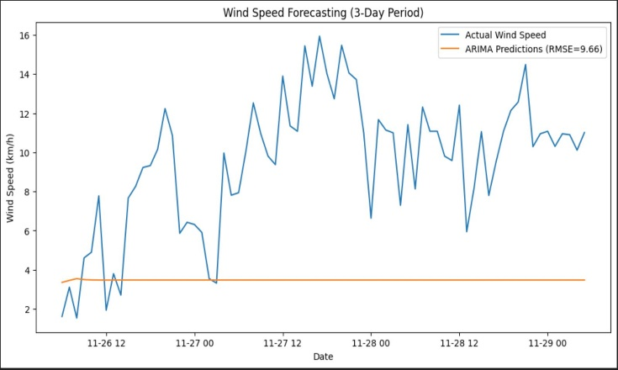

Fig. 3 Wind speed Forecasting (3 – Day period) – ARIMA

*D. SARIMA (Seasonal Autoregressive Integrated Moving Average):*

* 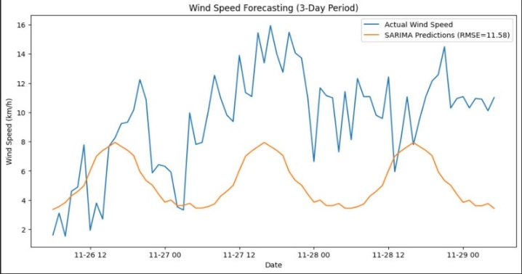Root Mean Squared Error (RMSE): 11.580844115741954

Fig. 4 Wind speed Forecasting (3 – Day period) – SARIMA

*E. XGBoost (Extreme Gradient Boosting):*

* Root Mean Squared Error (RMSE): 4.23366846962955

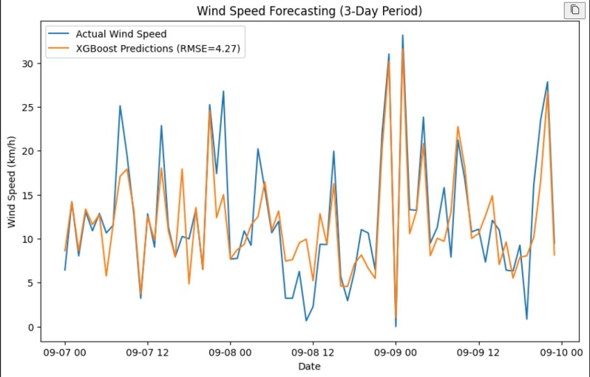

Fig 5. Wind speed Forecasting (3 – Day period) – XGBoost

*F. CNN+LSTM:*

* Root Mean Squared Error (RMSE): 0.6095664139427084

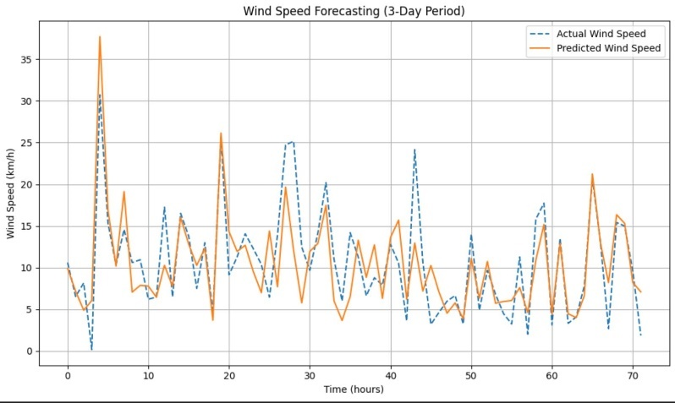

Fig 6. Wind speed Forecasting (3 – Day period) – CNN+LSTM

The CNN (Convolutional Neural Network)+ LSTM (Long Short-Term Memory) model presents a compelling fusion of techniques to handle sequential data. Despite achieving a relatively low Mean Squared Error (MSE), the Root Mean Squared Error (RMSE) is comparatively higher than other models. This suggests that while the model effectively captures temporal and spatial features, it may struggle with certain complexities in the data. Nevertheless, its ability to recognize intricate patterns makes it promising for tasks demanding sophisticated pattern recognition and analysis.

In contrast, the GRU (Gated Recurrent Unit) model outperforms the CNN+ LSTM combination with a lower RMSE. The simplicity of its architecture contributes to faster training and superior performance, especially in tasks involving sequential data processing such as speech recognition and time series forecasting. Its efficiency makes it a viable option for real-time applications where speed is paramount.

On the other hand, traditional statistical models like ARIMA (Autoregressive Integrated Moving Average) and SARIMA (Seasonal Autoregressive Integrated Moving Average) exhibit significantly higher RMSE values compared to neural network-based approaches. While ARIMA captures linear relationships in time series data, it struggles with nonlinear patterns, limiting its suitability for complex forecasting tasks. SARIMA, with its incorporation of seasonality, addresses some aspects of seasonal data but may falter when faced with nonlinear or irregular patterns.

Finally, XGBoost (Extreme Gradient Boosting) presents a moderate RMSE, positioning it between the neural network-based models and traditional statistical methods. As an ensemble learning algorithm, XGBoost combines the strengths of multiple decision trees, offering high prediction accuracy and robustness across a wide range of machine learning tasks.

VI. Conclusion

In the conclusion, we synthesize the findings from the results and analysis section to draw overarching conclusions and insights. Based on the observed performance metrics and analysis, we identify the most effective wind speed forecasting model and discuss the reasons behind its superiority. Additionally, this paper provides recommendations or implications based on the evaluation outcomes, guiding decision-making and future research directions in the field of wind energy forecasting.

Based on the provided models and their corresponding RMSE and MSE values, CNN (Convolutional Neural Network) + LSTM (Long Short-Term Memory) model emerges as the most suitable choice for wind speed forecasting.

The CNN +LSTM model exhibits competitive performance with relatively low MSE and RMSE values compared to the other models

evaluated. Despite a slightly higher RMSE compared to some models, its ability to capture both temporal and spatial features in sequential data allows for accurate analysis of complex patterns in wind speed data.

Additionally, the GRU (Gated Recurrent Unit) model also shows promising results with a lower RMSE compared to the CNN+ LSTM model. However, CNN+LSTM model demonstrates a slightly better overall performance, especially in capturing complex patterns in wind speed data.

Therefore, in conclusion, while both the CNN+LSTM and GRU models show potential for wind speed forecasting, the CNN+LSTM model is recommended as the preferred choice due to its robust performance metrics and versatility in handling various types of wind speed data.

References

[1] Jaume Manero. Wind energy forecast with neural network (2018)

[2] S.C Pryor. Climate change impacts on wind energy (2019)

[3] Not specified. Wind power forecasting using neural network: tuning with optimization techniques and errors analysis (2019)

[4] Harsh, Dipak. A Review on wind power and speed forecasting techniques (2020)

[5] Peng Lu, Lin Ye, Wuzhi Zhong, Ying Qu, Bingxu Zhai, Yong Tang, Yongning Zhao. A novel spatio-temporal wind power forecasting framework based on multi-output support vector machine and optimization strategy (2020)

[6] Enas Raafat Maamoun. Weather Forecasting Model (2021)

[7] Jie Liu, Quan Shi. A Hybrid GA–PSO–CNN Model for Ultra-Short-Term Wind Power Forecasting (2021)

[8] Yagang Zhang. Optimizing scheme of wind energy predictions based on AI (2021)

[9] Erlong Zhao. Wind energy forecasting with AI and big data (2022)

[10] Tolga Kara. Implications of Climate Change on Wind Energy Potential (2023)

[11] Wen-chang-tsai. A Review of Modern Wind Power Generation Forecasting Technologies (2023)

[12] Omer Ali Karaman. Prediction of Wind Power with Machine Learning Models (2023)

[13] M.A. Hannan, Ali Q. Al-Shewti. Wind Energy Conversions, Controls, and Applications: A Review for Sustainable Technologies and Directions (2023)

[14] ShiWen Wang, Jianzhou Wang. A structure for predicting wind speed using fuzzy granulation and optimization techniques (2024)